**Experiment 2**

**Aim:** To implement addition and subtraction of 8 bit and 16 bit numbers, multiplication of 8 bit numbers and division of a 16 bit number by an 8 bit number

**Prerequisite**: TASM assembler

**TASM(Turbo Assembler ):**

TASM itself is a 16-bit program.It runs on and produces code for 16- or 32-bit x86 MS-DOS and compatibles or Microsoft Windows. It will run on 16- and 32-bit versions of Windows, and produce code for the same versions, but it does not generate 64-bit x86 code. TASM is an assembler for x86 architecture, the job of assembler is to convert the assembly language program to machine language.

**Theory:**

To get the digits of an 8-bit number, we can use the masking operation. At first we will mask the upper nibble, and then the lower nibble. After masking the upper nibble, we have to rotate it to the right to make it least significant nibble. Then we can simply add it to the stored nibble to get the sum.

**1A)Addition of two 8 bit numbers**

**Algorithm:**

Step I : Initialize the data segment.

Step II : Get the first number in AX register.

Step III : Get the second number in BX register.

Step IV : Add the two numbers.

Step V : Display the result.

Step VI : Stop

**Code:**

Data segment

msg db 0dh,0ah,"Enter first number: $"

msg1 db 0dh,0ah,"Enter second number: $"

result db 0dh,0ah,"The Result is: $"

Data ends

Code segment

assume CS:Code,DS:Data

start:

mov ax,Data ; Move Data to Data Segment add8

mov DS,ax

mov dx,offset msg ; Display contents of variable msg

mov ah,09h

int 21h

mov ah,01h ; To accept input and store ASCII value into al(eg: 31h)

int 21h

sub al,30h ; Accept 10's place of the Number (31h becomes 01h)

mov bl,al

;mov cl,4

;rol bl,cl

rol bl,1

rol bl,1

rol bl,1

rol bl,1 ;(after rol cmds 01h becomes 10h)

mov ah,01h ; To accept input and store ASCII value into al (eg: 35h)

int 21h

sub al,30h ; Accept unit's place of Number (35h becomes 05h)

add bl,al ; Get the number by adding 10's and unit's place (10h + 05h = 15h)

mov dx,offset msg1 ; Display contents of variable msg1

mov ah,09h

int 21h

mov ah,01h ; To accept input and store ASCII value into al (32h)

int 21h

sub al,30h ; Accept 10's place of the Number(02h)

mov cl,al

;rol cl,4

rol cl,1

rol cl,1

rol cl,1

rol cl,1 ;(20h)

mov ah,01h ; To accept input and store ASCII value into al (33h)

int 21h

sub al,30h ; Accept unit's place of Number (03h)

add cl,al ; Get the number by adding 10's and unit's place (20h+03h=23h)

add bl,cl ; Add the two accepted Number's(15h + 23h = 38h)

mov dx,offset result ; Display contents of string result

mov ah,09h

int 21h

mov cl,bl ; Store the value of the Result

and bl,0f0h ; Isolate 10's place of Result(30h)

;mov cl,4

;ror bl,cl

ror bl,1

ror bl,1

ror bl,1

ror bl,1

call AsciiConv ; Convert to ASCII to display

mov dl,bl ; Display a Number/Alphabet

mov ah,02h

int 21h

mov bl,cl ; Retrieve original Result

and bl,0fh ; Isolate unit's place of Result(08h)

call AsciiConv ; Convert to ASCII to display

mov dl,bl ; Display a Number/Alphabet

mov ah,02h

int 21h

mov ah,4ch ; Terminate the program

int 21h

AsciiConv proc ; Compare to 0a if it is less than A then we need to add only 30

cmp bl,0ah ; If it is greater than or equal to 0a then we also need to add 07

jc skip

add bl,07h

skip: add bl,30h

ret

endp

Code ends

end start

**Output:**

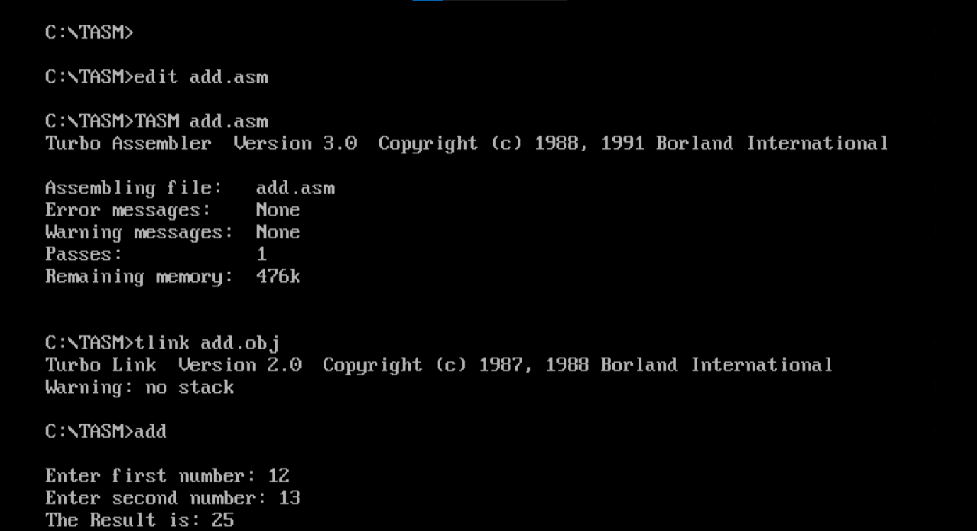

**Conclusion:**

From the user we are able to get two 8 bit numbers, then store the numbers we then need to add the two 8 bit numbers and store it in result. Atlast we can compile the assembly program in tasm.

**Aim:** Write an assembly language program for 8 bit subtraction.

**Prerequisite:** TASM assembler

**Theory:**

Consider that a byte of data is present in the AL register and a second byte of data is present in the BL register. We have to subtract the byte in BL from the byte in AL. Using sub instruction subtract the contents of two registers. Results will be stored in the AL register. Display the result using display routine.

**1B) Subtraction of two 8 bit numbers Algorithm:**

Step I : Initialize the data segment.

Step II : Get the first number in AX register.

Step III : Get the second number in BX register.

Step IV : Subtract the two numbers.

Step V : Display the result.

Step VI : Stop

**Code:**

Data segment

msg db 0dh,0ah,"Enter first number: $"

msg1 db 0dh,0ah,"Enter second number: $"

result db 0dh,0ah,"The Result is: $"

Data ends

Code segment

assume CS:Code,DS:Data

start:

mov ax,Data ; Move Data to Data Segment add8

mov DS,ax

mov dx,offset msg ; Display contents of variable msg

mov ah,09h

int 21h

mov ah,01h ; To accept input and store ASCII value into al

int 21h

sub al,30h ; Accept 10's place of the Number

mov bl,al

;mov cl,4

;rol bl,cl

rol bl,1

rol bl,1

rol bl,1

rol bl,1

mov ah,01h ; To accept input and store ASCII value into al

int 21h

sub al,30h ; Accept unit's place of Number

add bl,al ; Get the number by adding 10's and unit's place

mov dx,offset msg1 ; Display contents of variable msg1

mov ah,09h

int 21h

mov ah,01h ; To accept input and store ASCII value into al

int 21h

sub al,30h ; Accept 10's place of the Number

mov cl,al

;rol cl,4

rol cl,1

rol cl,1

rol cl,1

rol cl,1

mov ah,01h ; To accept input and store ASCII value into al

int 21h

sub al,30h ; Accept unit's place of Number

add cl,al ; Get the number by adding 10's and unit's place

sub bl,cl ; Add the two accepted Number's

mov dx,offset result ; Display contents of string result

mov ah,09h

int 21h

mov cl,bl ; Store the value of the Result

and bl,0f0h ; Isolate 10's place of Result

;mov cl,4

;ror bl,cl

ror bl,1

ror bl,1

ror bl,1

ror bl,1

call AsciiConv ; Convert to ASCII to display

mov dl,bl ; Display a Number/Alphabet

mov ah,02h

int 21h

mov bl,cl ; Retrieve original Result

and bl,0fh ; Isolate unit's place of Result

call AsciiConv ; Convert to ASCII to display

mov dl,bl ; Display a Number/Alphabet

mov ah,02h

int 21h

mov ah,4ch ; Terminate the program

int 21h

AsciiConv proc ; Compare to 0a if it is less than A then we need to add only 30

cmp bl,0ah ; If it is greater than or equal to 0a then we also need to add 07

jc skip

add bl,07h

skip: add bl,30h

ret

endp

Code ends

end start

**Output:**

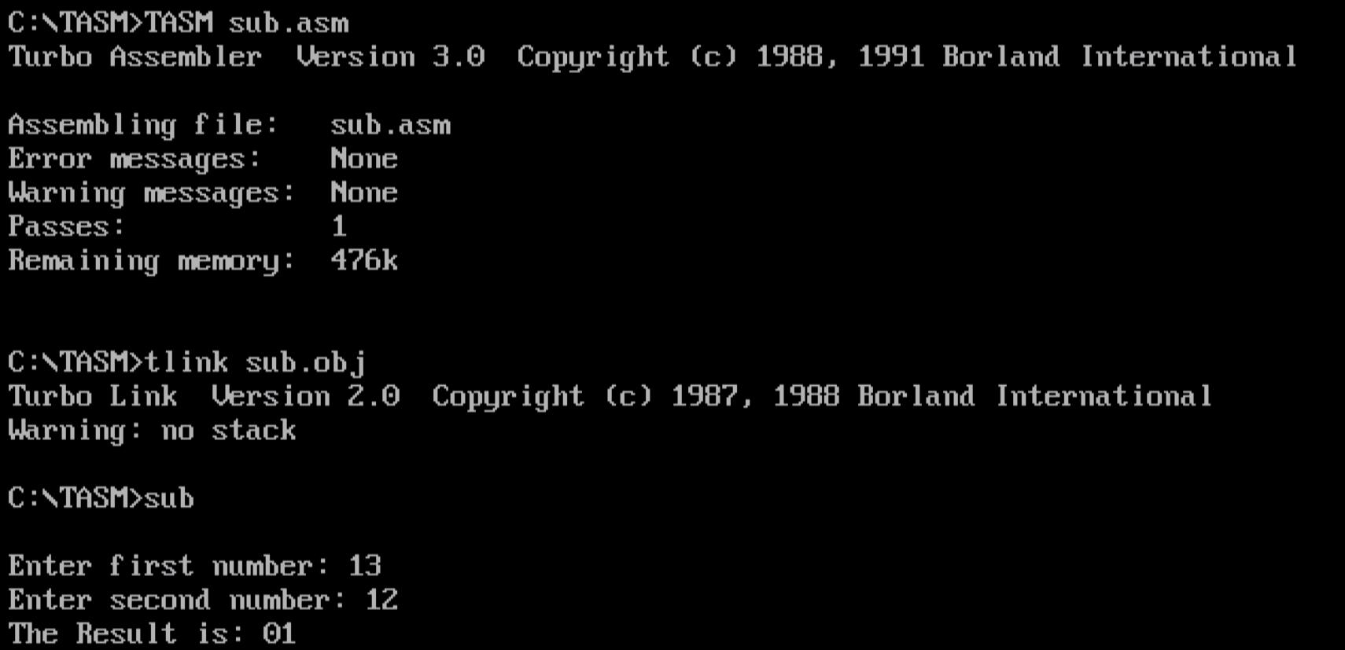

**Conclusion:**

From the user we are able to get two 8 bit numbers, then store the numbers we then need to subtract the two 8 bit numbers and store it in result. Atlast we can compile the assembly program in tasm.

**Aim:** Write an assembly language program for 16 bit addition.

**Prerequisite:** TASM assembler

**Theory:**

We use registers AX and BX to take the first and second number to find the sum of two numbers. Consider that a word of data is present in the AX register and a 2nd word of data is present in the BX register. We have to add words in AX with the word in BX. Using ADD instruction, add the contents. Results will be stored in the AX register. Display the result using display routine.

**2A) Addition of two 16 bit numbers**

**Algorithm:**

Step I : Initialize the data segment.

Step II : Get the first number in AX register.

Step III : Get the second number in BX register.

Step IV : Add the two numbers.

Step V : Display the result.

Step VI : Stop

**Code:**

Data Segment

msg db 0dh,0ah,"Enter a 16-bit number: $"

result db 0dh,0ah,"The Result is: $"

newl db 0dh,0ah," $"

Data ends

Code Segment

assume CS:Code,DS:Data

Start:

mov ax,Data

mov DS,ax

mov dx,offset msg;add16

mov ah,09h

int 21h

call AcceptNum

mov bh,bl

call AcceptNum

mov cx,bx

mov dx,offset msg

mov ah,09h

int 21h

call AcceptNum

mov bh,bl

call AcceptNum

add cx,bx

mov dx,offset result

mov ah,09h

int 21h

mov bl,ch

call DispNum

mov bl,cl

call DispNum

mov ah,4ch

int 21h

AcceptNum proc

mov ah,01h

int 21h

call HexAccept

mov bl,al

;rol bl,4

rol bl,1

rol bl,1

rol bl,1

rol bl,1

mov ah,01h

int 21h

call HexAccept

add bl,al

ret

endp

DispNum proc

mov al,bl

and al,0f0h

;ror al,4

ror al,1

ror al,1

ror al,1

ror al,1

mov dl,al

call HexDisp

mov ah,02h

int 21h

mov al,bl

and al,0fh

mov dl,al

call HexDisp

mov ah,02h

int 21h

endp

HexAccept proc

cmp al,41h

jc norm

sub al,07h

norm: sub al,30h

ret

endp

HexDisp proc

cmp dl,0ah

jc nothex

add dl,07h

nothex: add dl,30h

ret

endp

Code ends

end Start

**Output:**

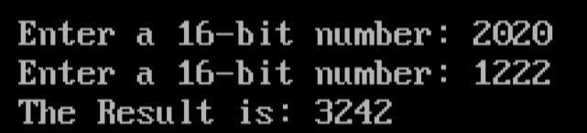

**Conclusion:**

From the user we are able to get two 16 bit numbers, then store the numbers we then need to add the two 16 bit numbers and store it in result. Atlast we can compile the assembly program in tasm.

**Aim:** Write an assembly language program for 16 bit subtraction**.**

**Prerequisite:** TASM assembler

**Theory:**

Consider that a word of data is present in the AX register and a second word of data is present in the BX register. We have to subtract the word in BX with the word AX. Using subtract (SUB) instruction, subtract the contents of two registers. Results will be stored in the AX register. Display the result using display routine.

**2B) Subtraction of two 16 bit numbers**

**Algorithm:** Step I : Initialize the data segment.

Step II : Get the first number in AX register.

Step III : Get the second number in BX register.

Step IV : Subtract the two numbers.

Step V : Display the result.

Step VI : Stop

**Code:**

Data Segment

msg db 0dh,0ah,"Enter a 16-bit number: $"

result db 0dh,0ah,"The Result is: $"

newl db 0dh,0ah," $"

Data ends

Code Segment

assume CS:Code,DS:Data

Start:

mov ax,Data

mov DS,ax

mov dx,offset msg;add16

mov ah,09h

int 21h

call AcceptNum

mov bh,bl

call AcceptNum

mov cx,bx

mov dx,offset msg

mov ah,09h

int 21h

call AcceptNum

mov bh,bl

call AcceptNum

sub cx,bx

mov dx,offset result

mov ah,09h

int 21h

mov bl,ch

call DispNum

mov bl,cl

call DispNum

mov ah,4ch

int 21h

AcceptNum proc

mov ah,01h

int 21h

call HexAccept

mov bl,al

;rol bl,4

rol bl,1

rol bl,1

rol bl,1

rol bl,1

mov ah,01h

int 21h

call HexAccept

add bl,al

ret

endp

DispNum proc

mov al,bl

and al,0f0h

;ror al,4

ror al,1

ror al,1

ror al,1

ror al,1

mov dl,al

call HexDisp

mov ah,02h

int 21h

mov al,bl

and al,0fh

mov dl,al

call HexDisp

mov ah,02h

int 21h

endp

HexAccept proc

cmp al,41h

jc norm

sub al,07h

norm: sub al,30h

ret

endp

HexDisp proc

cmp dl,0ah

jc nothex

add dl,07h

nothex: add dl,30h

ret

endp

Code ends

end Start

**Output:**

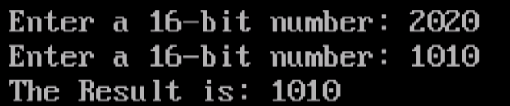

**Conclusion:**

From the user we are able to get two 16 bit numbers, then store the numbers we then need to subtract the two 16 bit numbers and store it in result. Atlast we can compile the assembly program in tasm.

**Aim:** Write an assembly language program for 8 bit multiplication.

**Prerequisite:** TASM assembler

**Theory:**

Program should load the first number and second number in registers AL and BL registers . Then it should implement some logic for multiplication of two numbers . Consider that a byte of data is present in the AL register and a second byte of data is present in the BL register. We have to multiply the byte in AL with the byte in BL. Using MUL instruction, multiply the contents of two registers. The multiplication of two 8 bit numbers may result in a 16 bit number. So the result is stored in the AX register. The MSB is stored in AH and LSB in AL.

**3) Multiplication of two 8 bit numbers**

**Algorithm:**

Step I : Initialize the data segment.

Step II : Get the first number in AL register.

Step III : Get the second number in BL register.

Step IV : Multiply the two numbers.

Step V : Display the result.

Step VI : Stop

**Code:**

.model small

.data

a db 09H

b db 02H

.code

mov ax, @data ; Initialize data section

mov ds, ax

mov ah, 0

mov al, a ; Load number1 in al

mov bl, b ; Load number2 in bl

mul bl ; multiply numbers and result in ax

mov ch, 04h ; Count of digits to be displayed

mov cl, 04h ; Count to roll by 4 bits

mov bx, ax ; Result in reg bx

l2: rol bx, cl ; roll bl so that msb comes to lsb

mov dl, bl ; load dl with data to be displayed

and dl, 0fH ; get only lsb

cmp dl, 09 ; check if digit is 0-9 or letter A-F

jbe l4

add dl, 07 ; if letter add 37H else only add 30H

l4: add dl, 30H

mov ah, 02 ; Function 2 under INT 21H (Display character)

int 21H

dec ch ; Decrement Count

jnz l2

mov ah, 4cH ; Terminate Program

int 21H

end

**Output:**

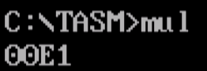

**Conclusion:**

We had set two 8 bit numbers, then store the numbers we then need to multiply the two 8 bit numbers and store it in a 16-bit register. Atlast we can compile the assembly program written in tasm and see the final output.

**Aim:** Write an assembly language program for Division of 16 bit number with 8 bit number.

**Prerequisite:** TASM assembler

**Theory:**

8086 has DIV instruction to perform division. Take the 8-bit number into BL, and 16-bit number into AX. Now divide AX by BL. The result will be stored at AX. We are taking two numbers, a 16 bit dividend and 8 bit divisor. Then we display the remainder as well as the quotient. The contents of quotient are moved in DI.

**4) Division of a 16 bit number by an 8 bit number**

**Algorithm:**

1. Assign values in SI and DI

2. Move the contents of [SI] in BL and increment SI by 1

3. Move the contents of [SI] and [SI + 1] in AX

4. Use **DIV** instruction to divide AX by BL

5. Move the contents of AX in [DI].

6. Halt the program.

**Code:**

.model small

.data

a dw 0000

c db 0

msg1 db 10,13,"Enter the 16 bit dividend: $"

msg3 db 10,13,"Enter the 8 bit divisor: $"

msgr db 10,13,"Remainder: $"

msgq db 10,13,"Quotient: $"

.stack 100

.code

.startup

mov ax, @data ; Initialize data section

mov ds, ax

lea dx,msg1

mov ah,09h

int 21h

numh1: mov ah,01h

int 21h

cmp al,'0'

jb ENTER_DIVIDENDH

CMP AL,'9'

JA NUMH1

SUB AL,48

MOV BH,0

MOV BL,AL

MOV AX,[A]

MOV CX,10

MUL CX

ADD AX,BX

MOV [A],AX

JMP NUMH1

ENTER_DIVIDENDH:

CMP AL,13

JNE NUMH1

LEA DX,MSG3

MOV AH,09H

INT 21H

NUML2:

MOV AH,01H

INT 21H

CMP AL,'0'

JB ENTER_DIVIDENDL2

CMP AL,'9'

JA NUML2

SUB AL,48

MOV BL,AL

MOV AL,[C]

MOV CL,10

MUL CL

ADD AL,BL

MOV [C],AL

JMP NUML2

ENTER_DIVIDENDL2:

CMP AL,13

JNE NUML2

MOV DX,0

MOV AX,[A]

MOV BH,0

MOV BL,[C]

DIV BX

MOV CX,DX

PUSH CX

MOV [A],AX

POP AX

MOV BP,SP

DIVR: MOV CL,10

DIV CL

MOV BH,AH

MOV BL,0

PUSH BX

MOV AH,0

CMP AL,0

JNE DIVR

DISP1: CMP BP,SP

JE DIVE

POP DX

MOV DL,DH

ADD DL,48

MOV AH,02H

INT 21H

JMP DISP1

DIVE: LEA DX,MSGQ

MOV AH,09H

INT 21H

MOV BP,SP

DIVQ:

MOV AX,[A]

MOV DX,0

MOV CX,10

DIV CX

PUSH DX

MOV [A],AX

CMP AX,0

JNE DIVQ

DISP2:

CMP BP,SP

JE DONE1

POP DX

ADD DX,48

MOV AH,02H

INT 21H

JMP DISP2

DONE1:

;.EXIT

END

mov ax, a ; Load number1 in ax

mov bl, b ; Load number2 in bl

div bl ; divide numbers. Quotient in al and Rem in ah

mov ch, 04h ; Count of digits to be displayed

mov cl, 04h ; Count to roll by 4 bits

mov bx, ax ; Result in reg bh

rol bx, cl ; roll bl so that msb comes to lsb

mov dl, bl ; load dl with data to be displayed

and dl, 0fH ; get only lsb

cmp dl, 09 ; check if digit is 0-9 or letter A-F

jbe l4

add dl, 07 ; if letter add 37H else only add 30H

add dl, 30H

mov ah, 02 ; Function 2 under INT 21H (Display character)

int 21H

dec ch ; Decrement Count

jnz l2

mov ah, 4cH ; Terminate Program

int 21H

end:

**Output:**

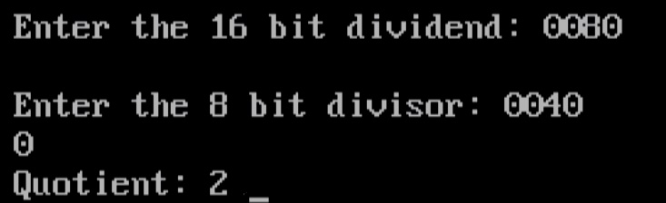

**Conclusion:**

To divide a 16 bit number by a 8 bit number we just have to take a dividend and divisor from the user and by using div we finally get the quotient and the remainder printed using tasm.